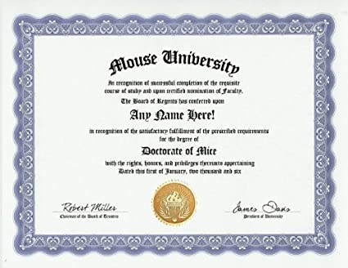
Need Continuing Education Units (CEUs) to maintain your registered “R” certification status BUT no meetings or training opportunities right now? No problem! Here are some ways you can still earn & submit CEUs to AALAS:
- Journal of AALAS Continuing Education Test Questions
- AALAS Learning Library courses
- Article published in LAS Pro
- Item writing for AALAS certification exams
- A full list can be found at this link:

